CLAIM FOR LOCAL TRANSPORTATION FUNDS
AND STATE TRANSIT ASSISTANCE FUNDS

TO: EL DORADO COUNTY TRANSPORTATION COMMISSION
2828 EASY STREET, SUITE 1, PLACERVILLE, CA 95667

FROM:
 | CLAIMANT: | Choose Agency
 | ADDRESS: | Click or tap here to enter text.
 |  | Click or tap here to enter text.

CONTACT PERSON: |  | Click or tap here to enter text.
 |  | Phone:Click or tap here to enter text. | Email:Click or tap here to enter text.

The Choose Agency hereby requests, in accordance with the State of California Public Utilities Code, commencing with Section 99200 and the California Code of Regulations commencing with Section 6600, that this claim for Local Transportation Funds be approved for Fiscal Year Choose FY, in the following amounts for the following purposes to be drawn from the Local Transportation Fund for LTF and State Transit Assistance Fund for STA deposited with the El Dorado County Treasurer:

LTF
P.U.C. 99260a, Article 4, Transit Operations: | Click or tap here to enter $
P.U.C. 99260a, Article 4, Transit Capital: | Click or tap here to enter $
P.U.C. 99275, Article 4.5, Community Transit Services | Click or tap here to enter $
P.U.C. 99400c, Article 8c, Contracted Transit Services: | Click or tap here to enter $
P.U.C. 99400e, Article 8e, Capital for Contracted Services: | Click or tap here to enter $
Total LTF (Table Layout, Formula, =Sum(Above) | Click or tap here to enter $
STA
Transit Operations (6730a): | Click or tap here to enter $
Transit Capital (6730a): | Click or tap here to enter $
Contracted Transit Services (6731b): | Click or tap here to enter $
Total STA (Table Layout, Formula, =Sum(Above) | Click or tap here to enter $

Authorized Representative:
By: |  |  | Title:
Name: |  |  | Date:

EDCTC Use:
Resolution No. Approving Claim: |  | Date of Approval:

ANNUAL VERIFICATION OF TDA COMPLIANCE TO ACCOMPANY
LTF AND STA CLAIMS FOR TRANSIT

PART I – ALL CLAIMANTS

1. Date annual TDA fiscal and compliance audit was approved:
Click or tap to enter a date.

2. Is the claimant's retirement system fully funded?
☐ YES
☐ NO

3. Is the claimant using the maximum Federal funds available for transit and/or streets/roads purposes?
☐ YES
☐ NO

PART II – TRANSIT CLAIMANTS

4. Date Transit Operator's Financial Transaction Report was submitted to State Controller's Office: Click or tap to enter a date. Attach copy of dated, signed cover sheet from report.

5. Are public transit vehicles routinely staffed with one driver?

☐ YES
☐ NO (Explain) Click or tap here to enter text.

6. Has the proposed transit operating budget changed by more than 15% compared to the previous year?
☐ Yes (Explain) Click or tap here to enter text.
☐ NO

7. Did the transit operator meet its minimum farebox recovery requirement during the previous fiscal year? (requirement: 12.22% El Dorado County Transit Authority)¹

☐ YES
☐ NO (see below)

If the farebox recovery requirement was not met, then the claimant must complete the following worksheet for the most recent fiscal year.

¹Assembly Bill 90, 2019-20 [Reg. Session] temporarily prohibits the penalty for non-compliance with farebox recovery ratio requirement during FY 2019-20 and 2020-21. The claimant should still identify whether the requirement was met. AB 149 of 2021 extends the non-compliance relief through FY 2022/23, and AB 125 of 2023 further extended it through FY 2025/26.

Transit Operating Expenses: | enter text. | +
Capital Purchases/Reserves: | enter text. | = | LTF spent in most
Subtotal: | enter text. | - | recent fiscal year
Federal Revenues: | enter text. | = | cannot exceed
STA Revenues: | enter text. | - | result below.
Total: | enter text. | * 0.5= | enter text.

8. Is there a prohibition on the employment of part-time drivers or on contracting with common carriers?
☐ YES
☐ NO (Explain) Click or tap here to enter text.

9. Are STA funds being used for transit operating purposes this fiscal year?
☐ YES (see below)
☐ NO

If STA funds are being used for transit operating purposes, indicate which efficiency standard was met. Use the STA Efficiency Standard 1 and 2 Excel worksheet to calculate the percentage allowable.

Efficiency Standard #1: ☐ Yes ☐ No²

Efficiency Standard #2: ☐ Yes ☐ No²

If neither efficiency standard was met, list the percentage of STA Funding limited to:
Capital Expenditures: Enter %% Operating Expenditures: Enter %.%

10. Describe or attach current fare structure:
Click or tap here to enter text.

11. Attach copy of latest CHP terminal inspection report.

12. Each transit claimant must report on efforts to implement recommendations included in the FY 2021/22 through FY 2023/24 Triennial Performance Audit, which was completed in 2025 (attach additional pages as necessary).
Click or tap here to enter text.

²Assembly Bill 90, 2019-20 [Reg. Session] temporarily prohibits the penalty for non-compliance with required STA efficiency standards during FY 2019-20 and 2020-21. The claimant should still identify whether the standards was met. AB 149 of 2021 extends the no-compliance relief through FY 2022/23, and AB 125 of 2023 further extended it through FY 2025/26.

Efficiency Standard #1 and #2 Calculation
Excel file on https://www.edctc.org

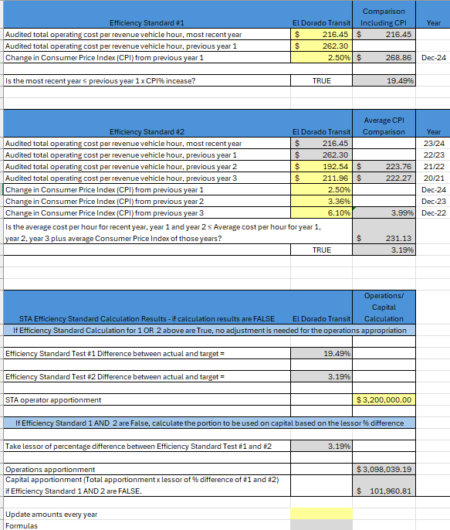

ANNUAL PROJECT AND EXPENDITURE PLAN

Claimant: Choose an item.

Fiscal Year: Choose an item.

Claimant: |  | Fiscal Period:
Project Title & TDA Article Number | SOURCES OF FUNDING
 | TDA/LTF | Transit Fares | Other | TOTAL
TOTAL REQUEST | $ | $ | $ | $

This form will show the planned expenditures of all TDA LTF funds claimed for the fiscal year in addition to any TDA TF funds carried over from previous years. Briefly describe all projects which will be funded by TDA LTF funds. Please show BOTH prior year TDA LTF funds (if any) and current year TDA LTF funds to be used, provide the total cost of each project, and indicate all other sources of funding associated with each project. The total project cost and total funding source(s) listed below should balance for each project.

For all STA carryover funding, include the Final Capital Improvement Plan Budget showing the STA carryover funding programmed to projects.

EL DORADO COUNTY TRANSPORTATION COMMISSION

TDA CLAIM FORMS

TRANSPORTATION DEVELOPMENT ACT (TDA) CLAIM FORMS MUST BE SUBMITTED TO EDCTC A MINIMUM OF THREE WEEKS PRIOR TO A EDCTC COMMISSION MEETING. FOR THE LATEST BOARD MEETING SCHEDULE, VISIT WWW.EDCTC.ORG

TDA LTF and STA Claim form:

A completed claim package includes the following completed forms:

- TDA Claim for Local Transportation Funds and State Transit Assistance Funds
  - STA Qualifying Criteria Worksheet – STA Efficiency Standard 1 and 2 Calculation (Excel file)
  - Efficiency Standard #1 and #2 Calculation (Excel file on http://www.edctc.org)
  - Annual Project and Expenditure Plan
  - CHP Inspection Reports (within 13 months)
  - Current fiscal year and next fiscal year budget
  - Final Capital Improvement Plan Budget showing projects funded with STA
  - Resolution from the claimant’s governing board approving the claim and submittal to EDCTC
  - If claiming Article 8c funds, copy of signed contract with whom claimant is contracting for transit service.

- TDA Claim for State of Good Repair Program Funds
  - Resolution from the claimant’s governing board approving the claim and submittal to EDCTC

- TDA Claim for Bicycle and Pedestrian Facilities
  - Resolution from the claimant’s governing board approving the claim and submittal to EDCTC
  - Summary of Expenditures and billings to other funding sources

